

Modern University for Technology & Information
Faculty of Computers and Artificial Intelligence

Project Title:[ Numerical Analysis Solver ]

Course: (BS-252) Numerical Analysis
Supervised by: Dr. Rania Ahmed
Teaching Assistant’s : [Abdalla Osama ]
[Mina Yakoub]

Study Group: [G-1]
Team Members:
- [Ahmed Abdalla Ahmed ] - [109994]
- [Ahmed Sameh Mostafa] - [111040]
- [Aboelela Magdy Sayed] - [110732]

Contents
Chapter 1 : Introduction 3
1. Introduction 3
2. Objectives 3
3. Tools & Technologies Used 3
1. Programming Language 3
2. GUI Framework 4
3. Libraries 4
4. IDE 4
5. Other tools 4
Chapter 2 : Application User Guide 4
Chapter 3 : Methods Implementation & Results 5
1. Chapter 1 : FINDING ROOTS OF POLYNOMIALS 5
1. Bisection Method 5
2. False position Method 6
3. Newton'sMethod 6
4. Simple Fixed point Method 6
5. Secant Method 6
Chapter 2 : LINEAR ALGEBRAIC EQUATIONS 7
1. Gauss Elimination 7
2. LU Decomposition 7
3. Cramer’s Rule 7
4. Gauss-Jordan 8

Chapter 1 : Introduction

Introduction
[Numerical analysis is the study of algorithms that use numerical approximation for the problems of mathematical analysis. This project aims to implement various numerical methods to solve non-linear equations, systems of linear equations, and optimization problems using modern programming techniques.]

[Numerical analysis is the study of algorithms that use numerical approximation for the problems of mathematical analysis. This project aims to implement various numerical methods to solve non-linear equations, systems of linear equations, and optimization problems using modern programming techniques.]

[Numerical analysis is the study of algorithms that use numerical approximation for the problems of mathematical analysis. This project aims to implement various numerical methods to solve non-linear equations, systems of linear equations, and optimization problems using modern programming techniques.]

Objectives
[Write short pullets describing the objectives of your application for example ]
- Develop a user-friendly GUI to solve complex mathematical problems.
- Implement Chapter 1 methods (Root Finding) and Chapter 2 methods (Linear Systems).
- Ensure high precision and handle mathematical errors (like division by zero).
- Provide step-by-step solutions for educational purposes.

Tools & Technologies Used

Programming Language
(e.g., Python, C#, Java “ you are free to use any “ ) describe why and where the team used these languages

GUI Framework
(HTML&CSS)

Libraries
(Math.js & bootstrap & html2pdf.js)

IDE
(VS Code)

Other tools

Chapter 2 : Application User Guide
Project Domain Link:
https://numerical-methods-solver.vercel.app/
How to Use the Application:
1-Select the required solving method from the Method dropdown list.
2-Enter the required input values.
3-Click the Solve button to perform calculations.
4-View the result and iteration steps.
5-Click Export to PDF to save the output.
1. Root-Finding Methods
For these methods, the user must enter a mathematical function in the f(x) field.
Examples:
x^2 - 4
sin(x) - x/2
log(x) - 1
Required inputs:
Bisection / False Position: lower bound xl and upper bound xu
Fixed Point / Newton: initial guess x₀
Secant: initial guesses x₀ and x₁
2. Linear System Methods
For matrix methods, enter the augmented matrix using the following format:
Separate rows with ;
Separate values with ,
Example:
2,1,5,8;1,-1,1,2;3,2,-1,3

Chapter 3 : Methods Implementation & Results
(Note: Each method below must follow the 2-page rule: Page 1 for Code, Page 2 for GUI Output)

Chapter 1 : FINDING ROOTS OF POLYNOMIALS

Bisection Method
- Page A: Code Snippet
- 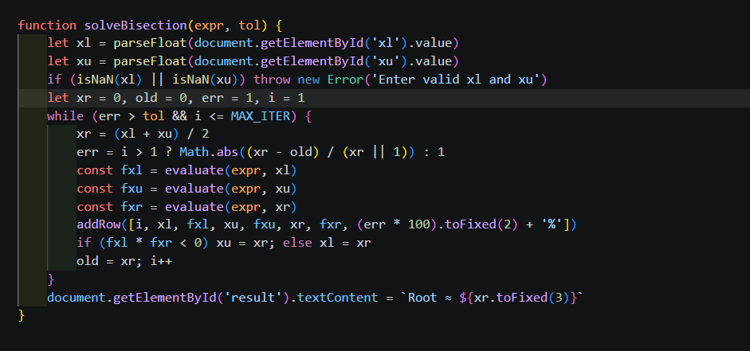 Page B: Output (GUI Screenshot) 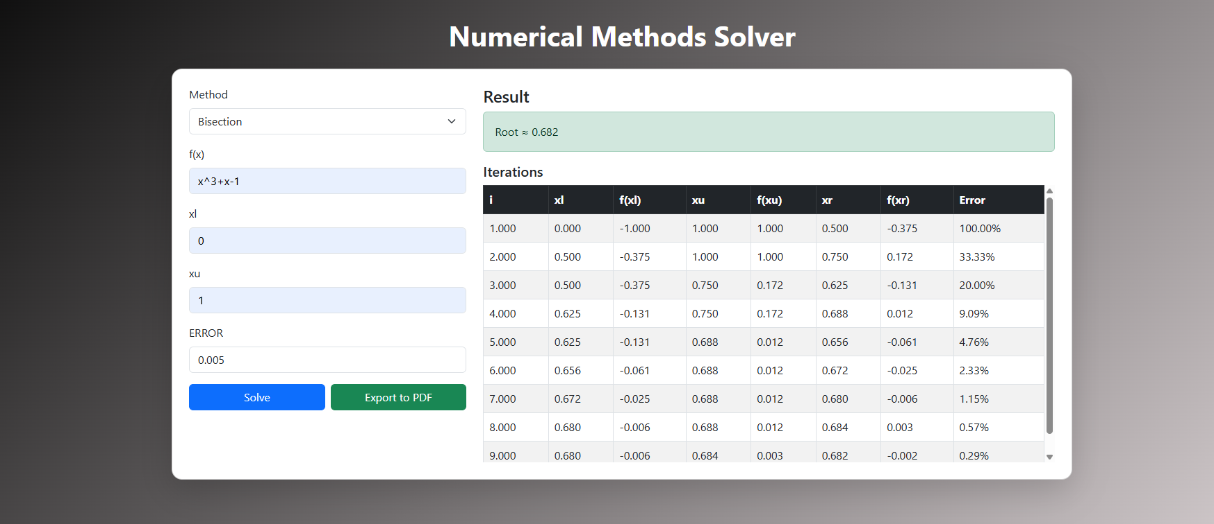

False position Method
- Page A: Code Snippet
- 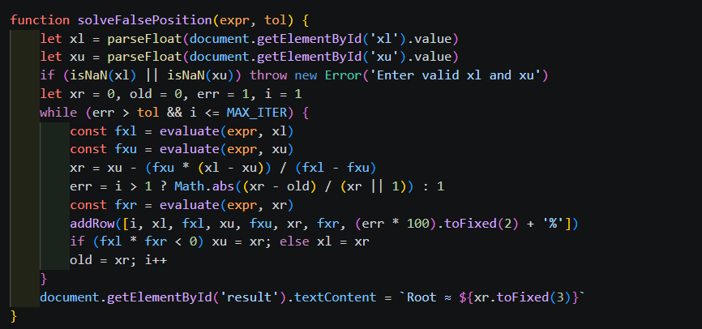 Page B: Output (GUI Screenshot)
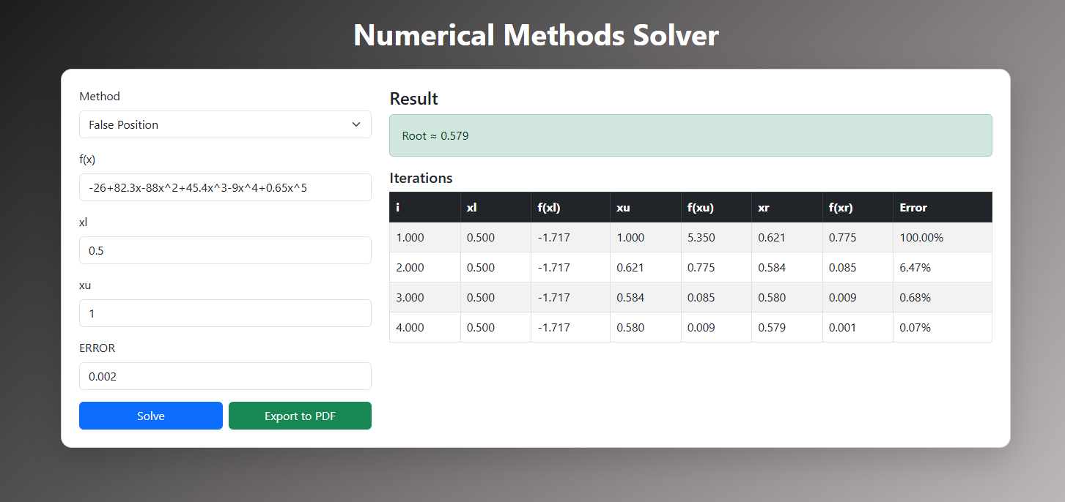

Newton'sMethod
Page A: Code Snippet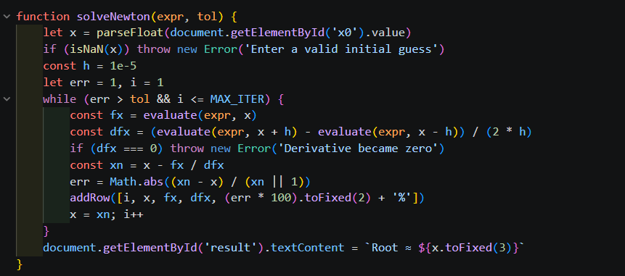
Page B: Output (GUI Screenshot)
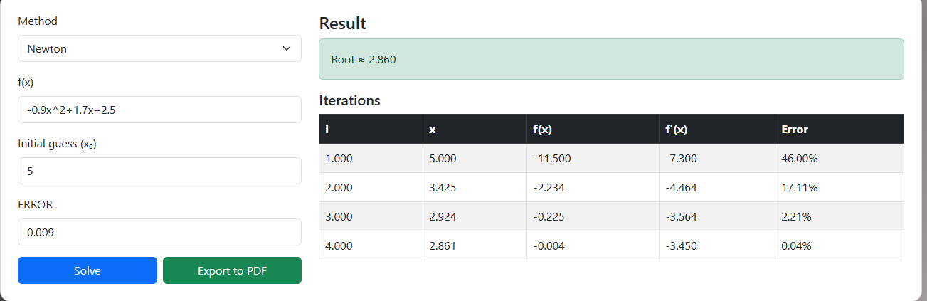

Simple Fixed point Method
Page A: Code Snippet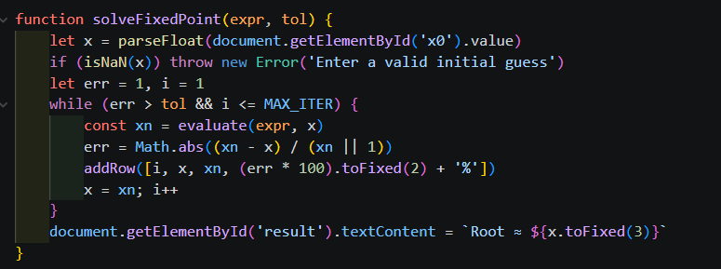
Page B: Output (GUI Screenshot)
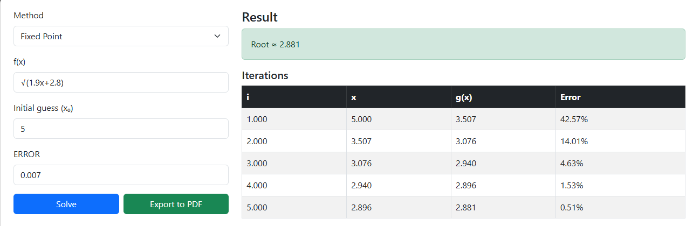

Secant Method
Page A: Code Snippet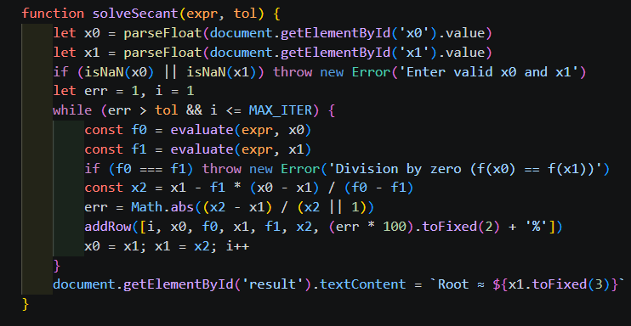
Page B: Output (GUI Screenshot)

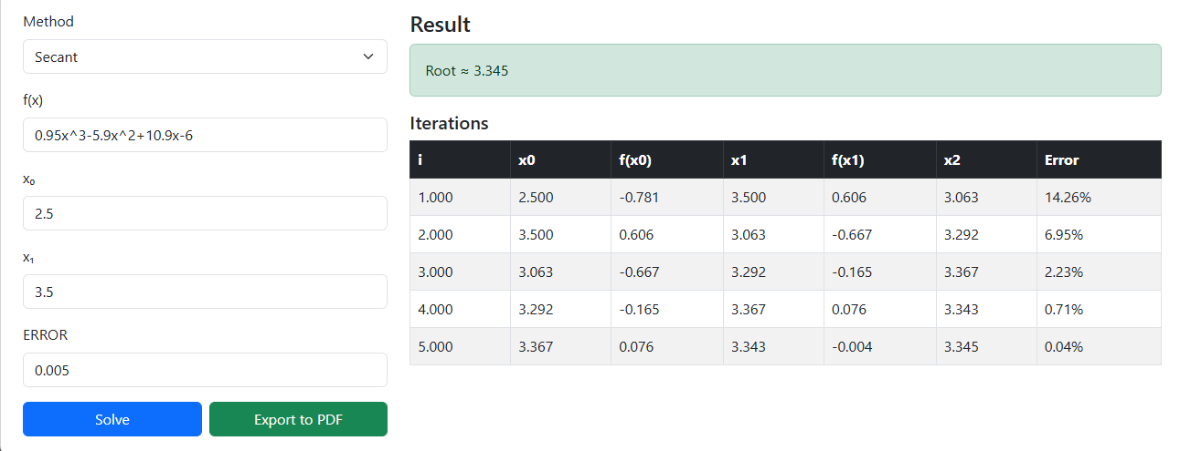

Chapter 2 : LINEAR ALGEBRAIC EQUATIONS

Gauss Elimination
Page A: Code Snippet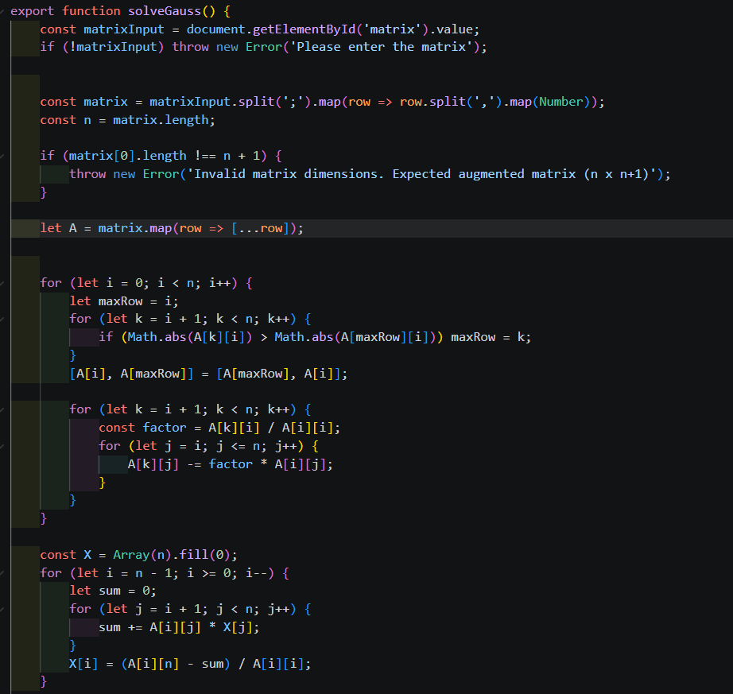
Page B: Output (GUI Screenshot) 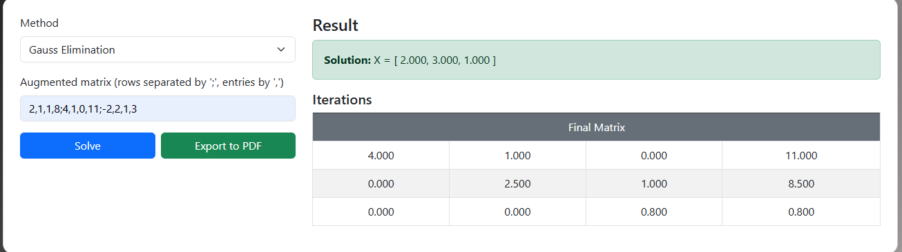

LUDecomposition
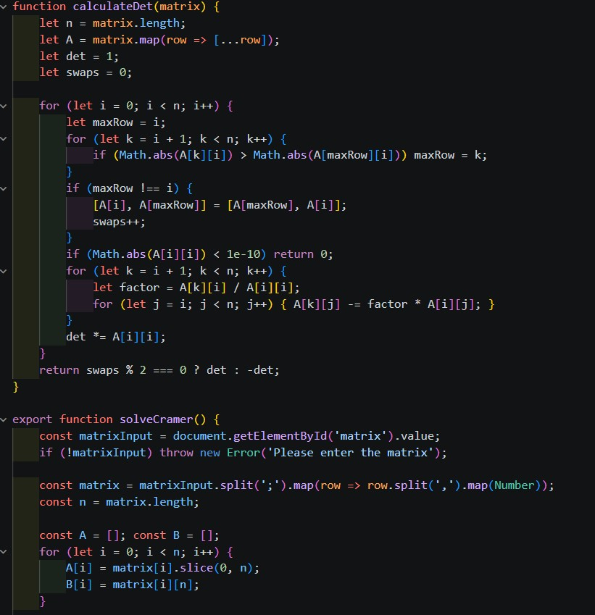

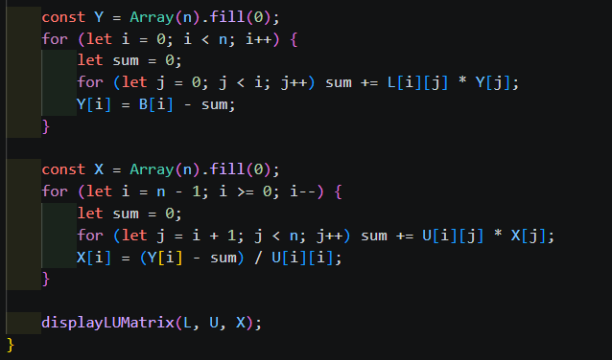
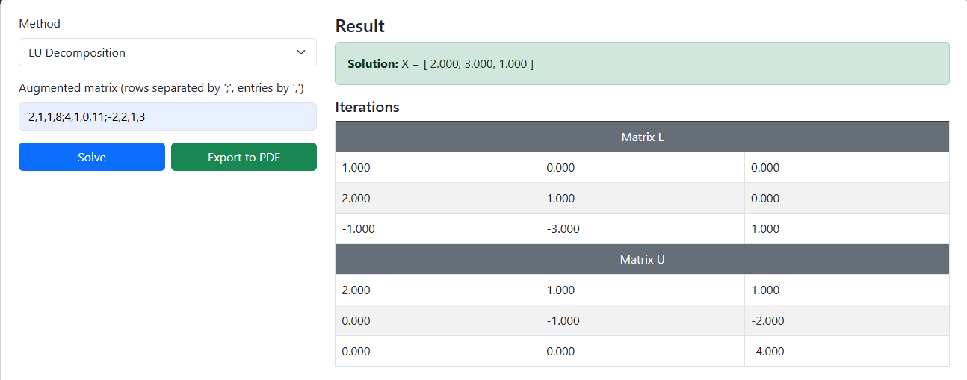

Cramer’s Rule
Page A: Code Snippet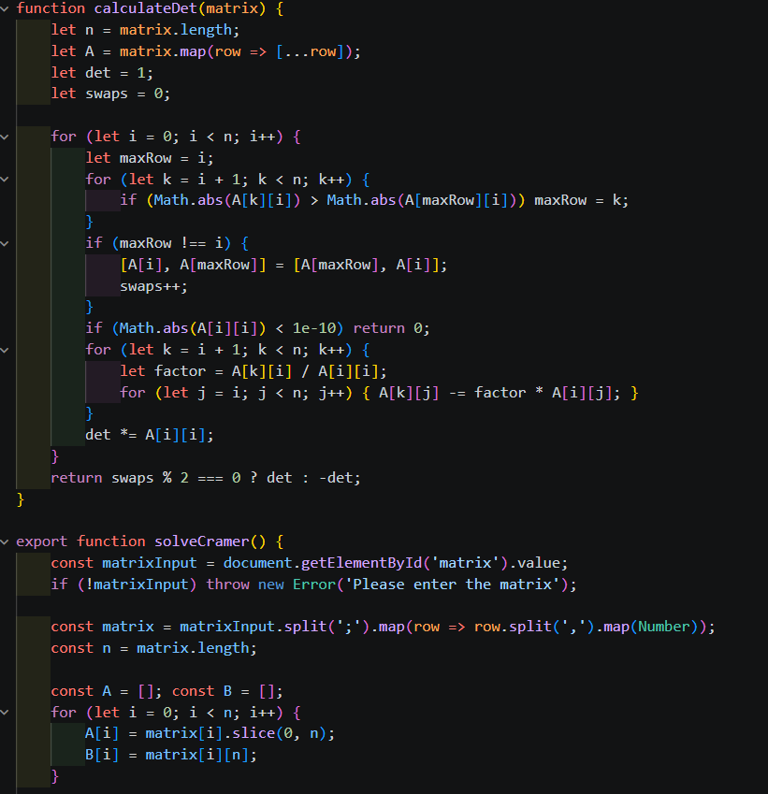
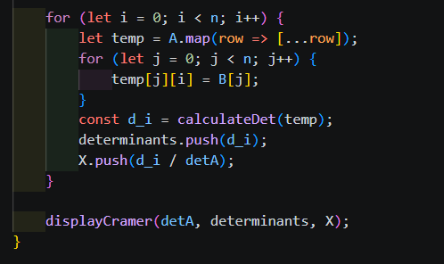
Page B: Output (GUI Screenshot) 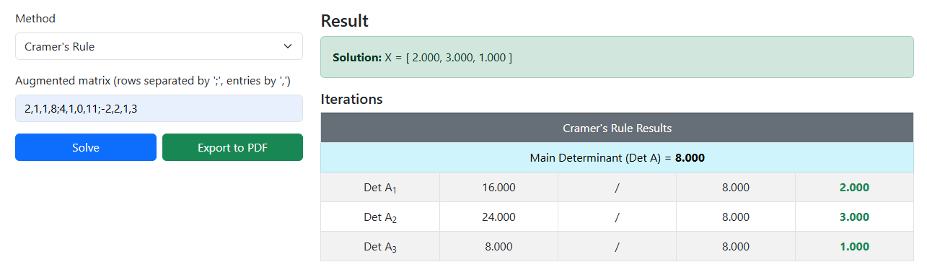

Gauss-Jordan
Page A: Code Snippet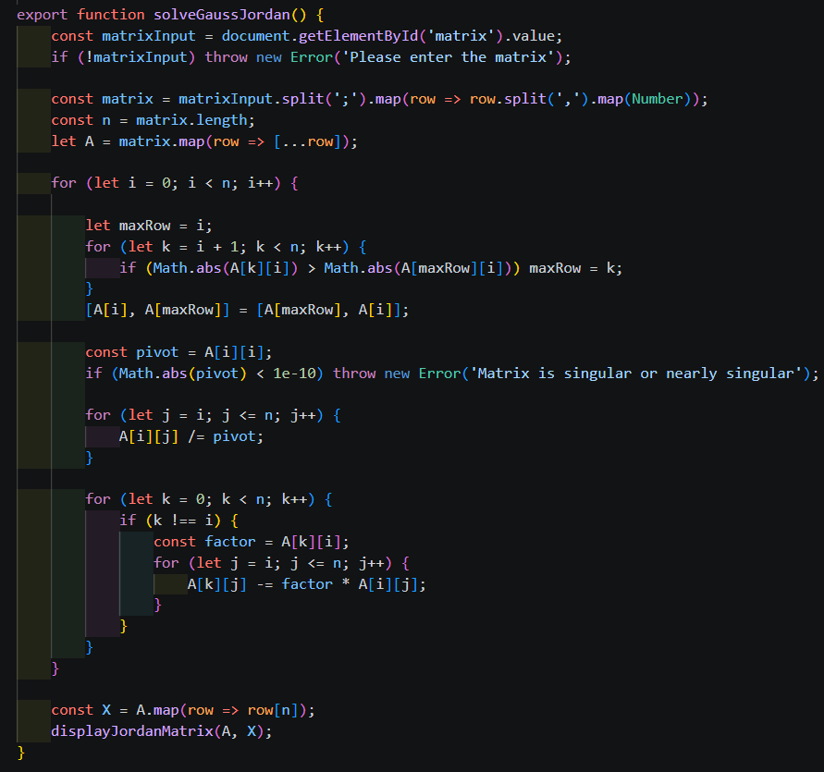

- Page B: Output (GUI Screenshot) 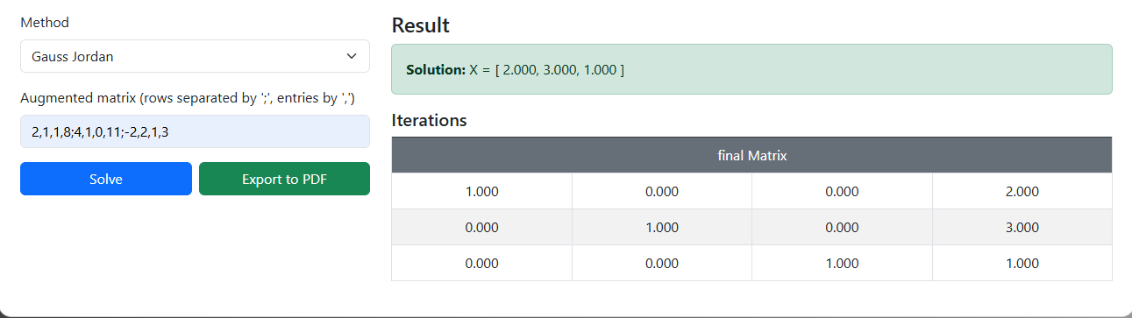

Summary & Conclusion
The web application that I made, my numerical methods solver, was built using HTML, CSS, and JavaScript. I was able to combine all types of numerical methods (bisection method, false position method, fixed point method, Newton method, secant method, gauss elimination method, LU decomposition method, gauss-Jordan method, Cramer’s rule) into one web application.
I developed the user interface so that users can easily type in their equation of a function or matrix and see step-by-step iteration results of solving that equation. Additionally, the web application can produce PDFs of the results
Using the html2pdf.script
I picked up some practical knowledge about how numerical methods actually work, as well as developed a stronger ability to understand how iterative algorithms find their solution. I developed greater skill relating to JavaScript programming, DOM manipulation, input validation, and organizing an entire web application project.

